

Your rock is telling you a story of how it was formed.

**Either it was formed by...**

2**. PARTICLES ERODED FROM OTHER ROCKS**

**(Sedimentary Rock)**

**…And lain down in layers**

**Like…**

**Mud (forming mudstone/shale)**

**Or…**

**Sand (forming sandstones)**

**Or…**

**Pebbles, sand, rocks (forming conglomerates)**

1. **EXTREME CONDITONS**

**Like…**

1. **It was once molten (melted)** **rock, cooling above or below ground.**

**(Igneous Rock)**

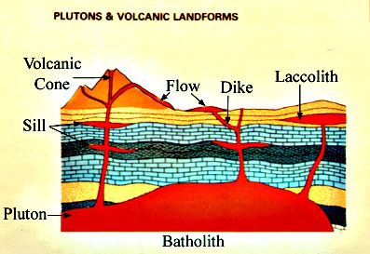

OR…

1. **It** **was put under GREAT heat and pressure, like when mountains are built.**

**(Metamorphic Rock**)

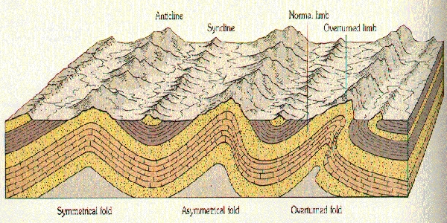

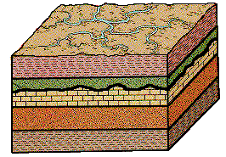

**This type of rock often has a texture like the sediments it came from-mud, sand, or gravel. It is sometimes softer than other rock, and may be layered.**

**This type of rock is often very dense and hard, and difficult to break. The particles are tightly interlocked. They may have crystals or shiny flecks in them.**

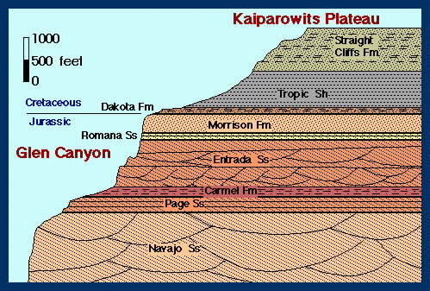

It was formed under



**ROCK STORY SORTING CHALLENGE: How did it form? (An intuitive, imaginative, artful process!)**

1. **What PHYSICAL PROPERTIES did you use to place a rock in the ‘EXTREME CONDITIONS’**

**category? What properties do those rocks have in common? Explain.**

1. **What PHYSICAL PROPERTIES did you use to place a rock in the ‘PARTICLES ERODED FROM OTHER ROCKS’ category? What properties do these rocks have in common? Explain.**
2. **Read YOUR pet rock’s story. How do you think your rock formed, by extreme conditions or by particles eroded from other rocks? Explain ALL of your reasoning.**

**LAB CHALLENGE: Classify 30 rocks, inferring how they formed. MASTERY LEVEL: /30**

Properties Geologists use to Classify Rocks

1. **Color: (Most to least) 1.**
2. **General Description 2.**
3. **Mineral Composition: 3.**

**How many KINDS of particles**

**are in it? Describe EACH.**

1. **Texture: 4.**
2. **Smooth, crystally, or grainy?**
3. **Does it feel like mud, sand, or gravel?**
4. **Are particles bound together, or**

**glued by natural cement?**

1. **Hardness (#1-10, soft to hard)**

**Describe, too.**

Scoring: Initials:

1-2-3-4-5 _____

1-2-3-4-5 _____

1-2-3-4-5 _____

**READING A ROCK STORY-Stranger than Fiction**