Mapping Magnetic Fields-Magnetism and Electricity
(Interactive Notebook)
Objective: I can teach myself about the connection between magnetism and electricity by observation, experimentation, and research.

- Compasses
- Learning by Research
Read ‘Compasses.’ Record 5 important pieces of information about how compasses work.
- Navigate with a Compass
- Building Compasses
1. Ring Magnet Compass
a. Neatly draw your ring magnet compass
beside an actual compass, showing precise
headings.
2. Needle Compass
http://www.stevespanglerscience.com/lab/experiments /homemade-compass
a. Neatly draw your needle compass beside an
actual compass, showing precise headings.

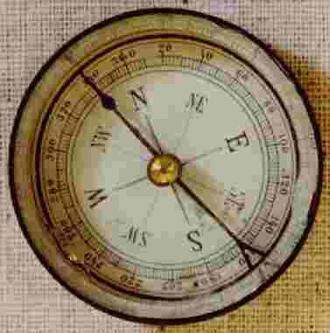 The Compass

Compasses are some of the oldest navigational tools in history. They have been crucial to major feats of navigation, such as the first transoceanic voyages and the circumnavigation of the globe. On a vast ocean, with an overcast sky, how else could a sailor know which way he was going, and more importantly, how to get home again?
A compass works by detecting the Earth’s natural magnetic fields. Like all magnetic fields the Earth’s magnetic field has two main poles, a north and south pole. These magnetic poles are slightly off from the Earth’s axis of rotation which is used as the basis of the geographic poles, but they are close enough that the general directions with adjustments for the polar difference, called a declination, can be used for navigation.
Essentially a compass is a light weight magnet, a magnetized needle, on a free rotating pivot. This allows the needle to better react to nearby magnetic fields. Since opposites attract the southern pole of the needle is attracted to the Earth’s natural magnetic north pole. This is how navigators are able to discern north.
The Earliest compasses were water compasses invented by the Chinese during the Song dynasty. These were a magnetized piece of metal floating in a bowl of water. Compasses came into common use in the 14th century in the west, leading to what is known as the Age of Exploration, and the voyages of Magellan, Columbus, Cook, and many others. Even now modern navigation still relies to some point on compasses and the more accurate world maps they helped to develop.

- Magnetic Field Scavenger Hunt

- Magnetic Fields in this Room: Use your compass to locate magnetic fields in this room. List the places you found them.
- Hypothesis: Can you make any inferences as to WHAT is causing the magnetic fields where you found them? Explain your team’s conclusion.

- Vocabulary

- Magnetism- a physical phenomenon produced by the motion of electric charge, resulting in attractive and repelling forces between objects.

- Electricity
http://studyjams.scholastic.com/studyjams/jams/science/energy-light-sound/electricity.htm

- Build an Electromagnet

Directions: Build your electromagnet. Then, use it to answer the questions in the lab (Q&A format, as always). Then, get curious and do some experimentation.
Materials:
- 1 yd. of wire, with ends stripped
- D-Cell Battery
- long iron nail
- paper clips
- compass
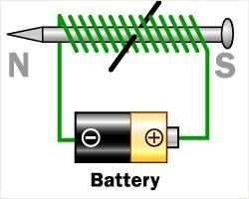
Procedure:
- Wrap the wire tightly around the nail, leaving about 4 inches of free wire on each end.
- Secure one end of the wire to one pole of the battery.
- BEFORE YOU CONTINUE…Use your compass to see if the apparatus has a magnetic field. Does it? You will need this information to answer question C.
- Touch the other free end of the wire to the opposite pole of the battery, creating a flow of electrons.
- With the wire ends attached to the battery, use the pointed end of the nail to touch paper clips.
- When the nail starts to feel warm, disconnect one of the wires you are holding against the battery.

Questions:
- What happened to the nail when you directed a flow of electricity around it?
- How many paper clips could you pick up with the nail in this configuration?
- Test this: Does a magnetic field exist around your set-up when the battery is DISCONNECTED? Use your compass to see.
- Test this: Does a magnetic field exist around your set-up when the battery is CONNECTED to the nail?
- Test this: How far out, in cm., does the magnetic field extend from the nail? How did you test this?
- Does the nail remain a magnet for a long period AFT-ER the electric current is broken, or does it dissipate (get less)?
- What IS an electromagnet?

V.Experiment: Get curious!

- Question: How can we make our electromagnet STRONGER?
Hypothesis:
Answer:

IF YOU HAVE TIME, HATCH ANOTHER TESTABLE QUESTION.

- Question:
Hypothesis:
Answer:

http://www.sciencekids.co.nz/videos/physics/magnets.html

