Magnetism Inquiry #2-Magnetic Fields
(Interactive Notebook)
Objective: To learn as much as possible about magnetic fields by observation, experimentation, and research.
Directions: Today, Partner #____will be reading directions, and your group will work together to figure out magnetic fields. Follow directions CAREFULLY. When you come to a question embedded in the lab instructions (A-H), talk about it together and write your BEST answer in your lab notebook in Q AND A FORMAT.

I. Learning by Observation
Bar Magnets/Earth’s Magnetic Field (Questions A-F)

A: Draw the bar magnet and compass positions as you see them below into your lab notebook.

S
N

Then, lay your compass at each of the points above. Note on your drawing the DIRECTION the red tip of the compass needle is pointing at each position.

When you finish recording, move your compass 360 degrees around the bar magnet. Note what the compass needle does. You are tracing the magnet’s invisible magnetic field.

B: How does the direction of the compass needle change as the compass is moved along the magnetic field?

Now, flip the plate over so it is ON TOP of the bar magnet, exactly as you traced it. CAREFULLY sprinkle a small amount of iron filings over the surface of the index card. Note where lines of filings appear to form. Sprinkle more filings on those areas GENTLY. OBSERVE.

C: Draw the magnet again (see below). Then draw the magnetic lines of force you see around the bar magnet, PRECISELY.
S
N

D: Do you see the same patterns in filings as you did with the compass tracing on Question A?

E: Where on your drawing is the magnetic field the STRONGEST? In other words, where are the lines of force CLOSEST TOGETHER?

F: Do the magnetic lines ever cross?

Now, you are going to figure out what happens to the STRENGTH of a magnetic field as distance from the magnet increases.

CAREFULLY, so as not to spill any filings, lift the card off of the magnet, and pour the iron filings into the Petri dish.

Then, have one partner hold the dish of filings, and the other partner put one pole of the bar magnet UNDERNEATH it, touching the plate. Have a third partner hold a centimeter ruler even with the top of the bar magnet.

The person holding the Petri dish SLOWLY lifts the dish, until the filings lay flat. Do several times until you are sure you have an accurate measurement, in cm..

G: What happens to the STRENGTH of the magnetic field as
distance from the magnet increases? How do you know?

Go to the rolling cart at the front of the room and check out the cow magnet to answer the following.

H: Do magnetic fields operate in two dimensions, like your paper
Plate, or in three dimensions, like the cow magnet? Explain.

II. Learning by Experimentation:
Develop a testable question(s) about magnetic fields. Ex) Does the shape of the magnet determine the shape of the magnetic field? Does the size of a magnet change the size of a magnetic field?
Design a test for your question, as you did in Magnetism Inquiry #1. Show your results with explanations and drawings.
A. Testable Question:
B. Hypothesis:
C. Procedure:
D. Data:
E. Conclusion:

III. Learning by Research:
Use the reading on the following page to research Earth’s magnetic field. You will use your research to answer A-C.

A: What causes Earth to have a magnetic field?
B: What are three affects of the magnetic field?
C: Neatly draw Earth’s 3-D magnetic field. Explain: Do the magnetic lines of force look the same as they did on your bar magnet?

EARTH’S MAGNETIC FIELD
What causes Earth to have a magnetic field? Where is our giant magnet? The Earth's core is believed to be a mix (alloy) of iron and nickel. In the outer core this mixture is melted and moving, giving the Earth its magnetic field.

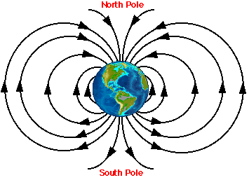
The magnetic field of Earth has many affects on us Earthlings. It allows us to navigate, using the magnetic field. It also enables many animals, such as birds and whales, to migrate.
More importantly, the Earth's magnetic field is responsible for deflecting the solar wind, charged particles of radiation that come from the Sun. Scientists believe that our atmosphere would be blown away by the solar wind, if it were not for the force field protection of Earth’s magnetic field. No air, no you!
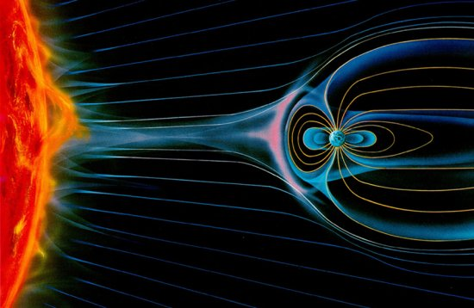
The magnetic field of Earth also causes a beautiful phenomenon called the Aurora, or northern and southern lights. Ionized particles from the sun hit our magnetic field, and travel north and south, where they slide down into the atmosphere, causing the dancing lights in the night sky.

